William Colon

4-1 Journal: Career Choice and Artifact Update

I am enhancing my career by integrating my computer science degree into my current work, rather than starting a new career path. This approach is allowing me to develop my skills further and progress professionally. Throughout my computer science program, I have acquired skills that have proven both excellent and invaluable. I blend my knowledge of computer science and my 25 years of experience with computers. In my upcoming role as a computer and network technician in the school system, this will provide me with a clear and straightforward path to follow. My degree's focus on cybersecurity also illustrates my ability to lead a team in software and hardware planning and development.

As part of the project, I have decided to select the artifacts for the appointment system. The advice that I received regarding my choices have been taken into consideration, and I am currently working on improving the following category, which is comprised of algorithms and data structures. Through the process of refining the code and adding additional comments in both the header and inline, I am attempting to guarantee that it is comprehensible and editable by any programmer. These comments will clarify the decision-making process that lies behind the code's general functionality. Currently, the eportfolio includes the most current posts that I have made. Enhancing the databases is something that I am still working on.

For the purpose of enhancing the architecture of my project, I improved both the algorithms, and the data structures associated with it. In this way, the system will be searched for any appointments that have been added.

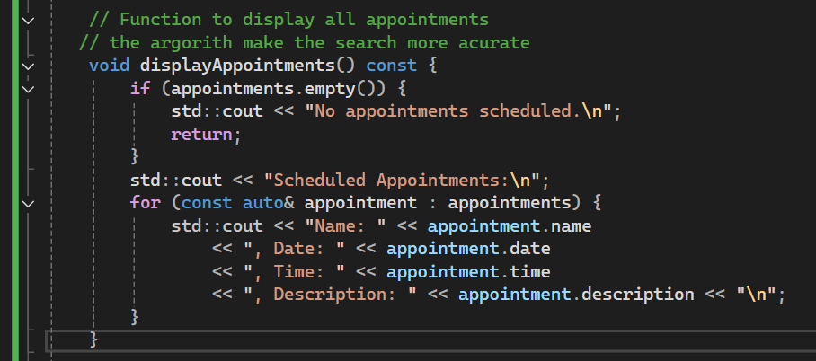

<https://github.com/williamcolon/CS-499/tree/82694ed5797d97f8391b03e7b3d34d11be553e9a/Appoitment>